


No1

Orientation to School of Nursing and Hospital…

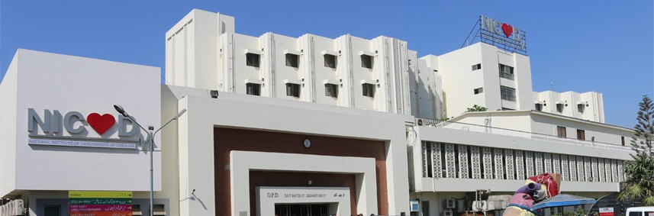

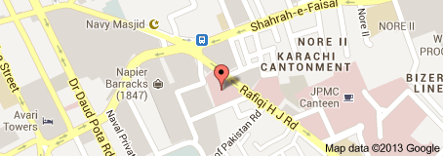
Location…

History
The National Institute of Cardiovascular Diseases (NICVD) was established in 1963. NICVD has grown from the 20-bed and now 500-bed hospital, serving more than 5000 patient every year. Dr. Ali Muhammad Qasim [19-12-1963 – 14-05-1964], a founder and first posthumous Executive Director of NICVD. The foundation stone was laid by then President Ayub Khan.
Emerging from the small Central Heart Clinic in Ward 10 of Jinnah Postgraduate Medical Centre (JPMC) in 1956, National Institute of Cardiovascular Diseases has been the primary heart-care provider for Pakistanis for over 50 years.
With support from the Government of Pakistan, USAID and the Japanese Government, NICVD became a fully functional tertiary cardiac-care centre on 14th August, 1971. For the following eight years, NICVD remained a Non-Governmental Organization (NGO) but in 1979 it was nationalized by the Government of Pakistan and became an Autonomous Body under the Federal Ministry of Health.
The present Governing Body of NICVD comes under the Government of Sindh with the Honorable Chief Minister of Sindh as the Chairman of the Board of Governors. The Executive Director of NICVD maintains the role of Secretary of the Board of Governors and Chief Executive Officer of the Institute and Chairman of the Academic Faculty.
Mission and Vision
- Mission
We aspire to be one of the world’s leading heart care facilities by:-
- Adopting a patient-focused approach that is respectful and sensitive to patient needs and values
- Acting on the ‘time is muscle’ principle to ensure prompt diagnosis and treatment to save and reduce heart damage
- Providing convenient access to those with financial constraints to prevent and treat heart related diseases without delay
- Educating the finest medical professionals of tomorrow in the field of cardiology
- Promoting a research-oriented environment to keep abreast with latest updates in cardiology
- Vision
We strive to keep every heart close to ours…
We aim to be the premier hospital in Pakistan for the prevention, diagnosis, treatment and rehabilitation of patients with cardiovascular diseases regardless of their socioeconomic status. Through our mission to deliver excellent patient care and commitment to training, research and development in cardiology, we strive to be the hospital of choice for both cardiovascular disease patients and medical professionals.

Background of NICVD
The National Institute of Cardiovascular Diseases (NICVD) was established in 1963 to meet the national need to cope with the increasing demand for the diagnosis, management and prevention of cardiovascular diseases and also to keep pace with the rapid technological advances in the practice of cardiology through research and development. NICVD was the first Cardiology Institute in this entire world region. The National Institute has its jurisdiction extending over the whole of Pakistan. It is the biggest and the pioneer institution of its kind in Pakistan and South Asia. Government of Pakistan gives an annual grant-in-aid to the Institute but the bulk of its budgetary provisions are met with from its endowment funds, private donations and the revenue earned from paying patients. The bulk of work done. At the Institute is either totally free or heavily Subsidized.

EXECUTIVE DIRECTOR
PROFESSOR NADEEM QAMAR
PROFESSOR OF CARDIOLOGY
(DIPLOMATE AMERICAN BOARD OF INTERNAL MEDICINE)
Executive Director of National Institute of Cardiovascular Disease (NICVD), the largest public teaching hospital in Pakistan…
Departmental Structure
The departmental structure of the hospital is as follows:
- Department of Adult Cardiology.
- Department of Cardiac Surgery.
- Department of Anesthesiology and Intensive Care
- Department of Pediatric CardiologyDepartment of Pediatric Cardiac Surgery
- Department of Clinical Pathology
Department of non-Invasive studies.
(a). Nuclear Cardiology.
(b). Department Of Echocardiography.
(c). Exercise Tolerance Test
Cardiac Catheterization / Interventional Cardiology and Electrophysiology Laboratory.
- Department of Cardiac Rehabilitation and Preventive Cardiology.
- Supportive and Administrative Departments.
- Information Technologies.

Satellite Centres
National Institute of Cardiovascular Diseases, Nawabshah
National Institute of Cardiovascular Diseases, Sukkur
National Institute of Cardiovascular Diseases, Sehwan
National Institute of Cardiovascular Diseases, Hyderabad
National Institute of Cardiovascular Diseases, Tando Muhammad Khan
National Institute of Cardiovascular Diseases, Larkana
Currently we have our Chest Pain Units at six different locations of Karachi to facilitate the citizens.
NICVD Chest Pain Unit Gulshan Chowrangi Flyover
NICVD Chest Pain Unit Gulbai Flyover
NICVD Chest Pain Unit Qayyumabad Chowrangi Flyover
NICVD Chest Pain Unit Malir Halt Flyover
NICVD Chest Pain Unit Nagan Chowrangi Flyover
NICVD Chest Pain Unit at Railway Road, opposite Miskeen Gali near I.I. Chandrigar Road.
Department of Adult Cardiology
Emergency Room:
New Emergency was inaugurated on 13th September 2008. There are separate male and female wings with 34 beds on the male side and 20 beds on the female side. Almost 1000 to 1500 patients attend causality every day out of which 70-100 are admitted. The emergency room is fully equipped with monitors and pulse oxymeter with each bed and ventilator Hamilton C2 and Benet. All life saving medicine are provided free of cost to patients.
Patients rushed in with cardiac emergencies manifested by chest pains, shortness of breath, palpitations and other symptoms are provided rapid appropriate treatment by our trained physicians, cardiologists, skilled nurses and nurse aid.
Coronary Care Units:
There are 3 coronary care units, affiliated with the 3 general and 2 private wards. These intensive care units provide 24 hours monitoring and intensive care to 32 patients in all.
Emergency Room
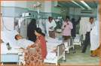
Emergency Room
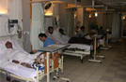
Coronary Care Unit
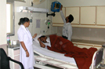

Department of Cardiac Surgery

Strength:  The two surgical wards of the Institute have more than 40 beds each for male and female patients. There are 4 operation theatres. The Intensive Care unit has 21 beds for adults and children. Construction is underway for 3 more operation theaters and soon there will be 7 theaters functioning in all.  Operations Performed:  The operations performed daily are as follows: Coronary Artery Bypass grafting. All types of Valvular Heart Surgery (Open and Closed heart). Pediatric Cardiac Surgery, Palliative Corrective and miscellaneous surgeries. By the end of the year 2002, 14607 Open Heart Operations had been performed at National Institute of Cardiovascular Diseases; 488 closed heart procedures were carried out.  Academic Activities:  The Department of Cardiac Surgery, NICVD, was the first in the country to be approved for training of Fellows in Cardiac Surgery from College of Physicians and Surgeons Pakistan and has been working ever since to bring expertise and excellence into this field. 17 Cardiac Surgeons have qualified for FCPS. and are now serving in various hospitals in Pakistan and abroad. Two surgeons have qualified in M.S, Cardiac Surgery from the University of Karachi. | 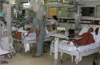
 | 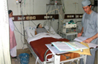

Department of Anesthesiology & Intensive Care Unit NICVD Karachi

Department of anesthesiology NICVD was established in the year 1963 with the beginning of this hospital. Since then the departmental work and responsibilities have increased tremendously. Now the department is managing anesthesia for all types of cardiac surgeries including CABG, valvular heart surgery, congenital defects and closed heart surgeries. Besides this, the department is also providing emergency anesthesia service to coronary care units, catheterization laboratory, and emergency department of the hospital. There are four operation theatres for open heart surgery, one operation theatre for closed heart surgery along with twenty one beded intensive care unit.  Academic Activities:  The department is recognized for MCPS and FCPS training from College of Physicians and Surgeons Pakistan. The department is in collaboration with the department of anesthesia JPMC Karachi for teaching and training of their resident medical officers and post graduate students. Post graduates for fellow ship are trained for intensive care management, invasive and non invasive monitoring, IABP and ventilatory management of patients. The department is planning for regular workshops on ICU management, BLS ACLS and FCLS. In the year 2002 four candidates from the department have passed FCPS-I and two have passed MCPS anesthesiology examination.
  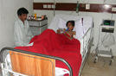
  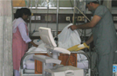

Department of Paediatric Cardiology

The first fully fledged professorial Paediatric Cardiology Department in Pakistan was established in N.I.C.V.D. in 1980. This department was the first one to be recognized by College of Physicians and Surgeons of Pakistan for Paediatric Cardiology Fellowship training and till now three candidates from this department have successfully achieved FCPS Certification in Paediatric Cardiology.  The In Patient Service consists of a 35 bedded unit equipped to deal with all age groups of children with heart diseases. Approximately 1500 patients are admitted per year. Out Patients are seen at twice weekly clinics where on the average 12000 patients per year are seen. Patients come from all over Pakistan. Radiology and 2D and Doppler Echocardiography are available on 24 hourly basis. About 3000 pediatric echocardiograms are performed per year. About 400 diagnostic pediatric cardiac catheterization are performed each year. Various catheter based interventional procedures are performed in this department which include: Atrial Septostomy, Pulmonary and aortic valvuloplasty, P.T.M.C., Dilatation of coarctation of aorta and stent implantation, PDA closure by coil and, ASD closure by devices.  There is an active pediatric cardiac surgery service available and 350 operations, both close heart & open heart, per year are performed. Closed heart operations include, PDA ligation, PA banding, modified Blalock Taussig shunt, repair of coarctation of aorta, Glenn Operation, closed mitral commissurotomy etc. Open heart operations include closure of ASD & VSD, valve repair & replacement, total correction for T.O.F., TAPVR, Fontan operation etc. | 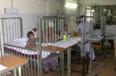
 | 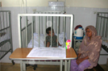
 | 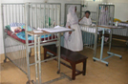
 | 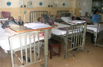

Department of Adult & Paediatric Cardiac Surgery

Strength
The three surgical wards of the Institute have more than 80 beds. Two wards are for adults and one for Paediatric surgical patients. There are 8 operation theatres. The Intensive Care unit has 21 beds for adults and children. Construction is underway for Paediatric intensive care unit and step-down high dependency unit

Operations Performed
Nearly 1500 procedures are performed every year.
Adults | Paediatric
Coronary Artery Bypass | Closed heart operations include | Open heart operations include
Valve reconstruction and replacements | PDA ligation | ASD Closure
Valve reconstruction and replacements | PA banding | VSD Closure
Adult congenital | Modified Blalock Taussig shunt | Mitral Valve repair & replacement
Aortic root and Arch Surgery | Repair of coarctation of aorta | Aortic Valve repair& replacement
 | Glenn operation | Total correction for T.O.F.
 | Closed mitral commissurotomy. | TAPVR repair
 |  | Fontan operation.
 |  | Senning operation.
Academic Activities:
The Department of Cardiac Surgery, NICVD, was the first in the country to be approved for training of Fellows in Cardiac Surgery from College of Physicians and Surgeons Pakistan and has been working ever since to bring expertise and excellence into this field. 17 Cardiac Surgeons have qualified for FCPS and are now serving in various hospitals in Pakistan and abroad. Two surgeons have qualified in M.S, Cardiac Surgery from the University of Karachi.
Academic Activities:
The Department of Cardiac Surgery, NICVD, was the first in the country to be approved for training of Fellows in Cardiac Surgery from College of Physicians and Surgeons Pakistan and has been working ever since to bring expertise and excellence into this field. 17 Cardiac Surgeons have qualified for FCPS and are now serving in various hospitals in Pakistan and abroad. Two surgeons have qualified in M.S, Cardiac Surgery from the University of Karachi.
Academic Activities:
The Department of Cardiac Surgery, NICVD, was the first in the country to be approved for training of Fellows in Cardiac Surgery from College of Physicians and Surgeons Pakistan and has been working ever since to bring expertise and excellence into this field. 17 Cardiac Surgeons have qualified for FCPS and are now serving in various hospitals in Pakistan and abroad. Two surgeons have qualified in M.S, Cardiac Surgery from the University of Karachi.

Department of Pathology

The Department of Pathology includes the sections of Biochemistry, Hematology, Microbiology, Serology, Histopathology/Cytology and Blood Bank.  Laboratory services are available round the-clock for all NICVD patients. Routine as well as stat tests are performed including analysis of Cardiac Markers i.eCTrop-I, C Trop-T and CK-MB, Arterial blood gases, Lipid profile, C-Reactive Protein (CRP), Coagulation Profile (PT (INR), APTT and Anticoagulant clinic tests are carried out for out patients. three times a week. All tests are performed by auto analyzers, including Moduler P/800 (Hitachi), Elecys (Hitachi) Dimension RxL max, Beckman Coulter Cx-9, Cysmex (Kx-21) and ABL555 at high standard. The last decade has witnessed a fourfold increase in the total number of tests performed by the department. About 400-500 patients are handled by pathology/ Laboratory /day.  The department participates in two external quality control programs.  1. National External Quality Assurance Program Pakistan (NEQAPP) based at Armed  Forces Institute of Pathology, Rawalpindi.  2. International Quality Assurance Survey, (IQAS), Singapore.  The NICVD blood bank is registered with Sindh Blood Transfusion Authority. It is also among Safe Blood Transfusion Centers conducting screening for HIV, HbsAg and HCVa according to WHO guidelines provided by Ministry of Health Islamabad.  The faculty members participate in the teaching and training programs for doctors, nurses and paramedical staff at NICVD. They also provide able guidance to post graduate students in the laboratory aspects of their research work. | 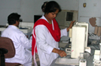
 | 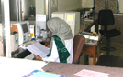
 | 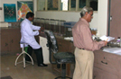
 | 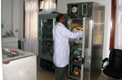

Department of non-Invasive Studies

a). Department Of Echocardiography:  The Echo Cardiography department, one of the busiest in the Institute caters to both admitted and out patients. Approximately 1000 adult cases are echocardiographed each month. Other modalities include Dobutamine stress Echo (DSE) and Transoesophageal Echocardiography for assessment of left atrial clots, Vegetations and Aortic Dissections. Between 10-20 cases are performed using these advanced techniques each month. About 240 infants and children both admitted and out patients are brought in monthly and some very complicated congenital and valvular heart diseases are diagnosed through Echo and Doppler studies.  (b). Nuclear Cardiology:  Department of Nuclear Cardiology in NICVD, came into being in 1987, when the need to accurately investigate myocardial perfusion defects was acutely felt. Initially a single Head camera was installed for Thallium planar scan, using radio isotope Thallium 201. Using this facility, 450-500 cases were performed each year in the Institute. In 2002 the department was upgraded. A double head camera with various angles for myocardial perfusion studies was brought in. The quality of imaging has become far more superior and has enabled the department to perform almost 3000 cases per anum.  (c). Exercise Tolerance Test | 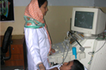
 | Dept. of Echocardiography
 | 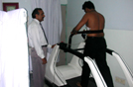
 | Thallium Stress Test
 | 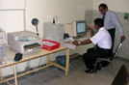
 | Thallium Stress Test
 | 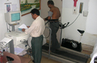

Cardiac Catherizatrion / Interventional Cardiology

The department of Cardiac Catheterization &Angiography consists of 7cath labs with State of Art facilities. The ancillary facilities include I A B P, I V U S and Rotablader. NICVD is a high volume Tertiary Care Center with over 10,000 Coronary Angiographies, Intervention for coronary and structured heart disease, Cardiac caths and EP studies are carried out every year. Over 30,00 interventional procedures are done yearly that include PCIs (primary (24/7 Days), rescue and elective), valvuloplasties, Closures (PDA, ASD), coarctation of aorta repair, renal and carotid angioplasties, Ablation Therapy, ICD implant and cardiac assist devices. This institute regularly organizes interventional cardiology workshops to demonstrate the current and future techniques that are available for the performance of percutaneous intravascular and intracardiacinterventions. The department is recognized for post fellowship interventional program for CPSP | 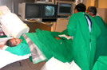
 | 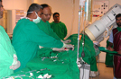
 | 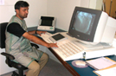

Department of Rehabiliation and Preventive Cardiology

 | Cardiac Rehabilitation and Secondary Prevention, was established in the National Institute of Cardiovascular Diseases in January 1996. Cardiac Rehabilitation at NICVD is characterized by comprehensive services, involving medical education, prescribed exercise, cardiac risk factor modification, education, counselling and behavioural interventions. Patients are enrolled into this program during hospital stay, these patients include those who have had Bypass Surgery, patients with stable Angina pectoris, those after Angioplasty and patients with Heart failure also attend.  Classes are held twice weekly (every Tuesday and Saturday) within the Hospital premises. Patients are encouraged to attend this program, on twice weekly basis for at least six weeks. Family members, especially women, are encouraged to come.  Pamphlets and hand outs are provided to the patients on their visits to the Rehab class. Each class comprises of :  1. An Exercise Component  2. Group Counselling  Patients are not charged and all services are provided free of cost. | 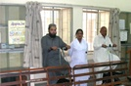

Information Technologies

This new dept. has been initiated to ensure that the hospital functions more efficiently. The entire hospital is connected via an internal network. The department has been customizing indigenous software in an integrated fashion. Software to assist with medical procedural data, financial transactions, inventory management care being implemented.
Organizational Chart Of College Of Nursing

Organizational chart of NICVD Karachi…

Organizational chart of NICVD
Karachi(cont)…

Organizational chart of NICVD Karachi…(Cont)

National Institute of Cardiovascular diseases Pakistan…
- NICVD staff quantity list 2019
S.NO | NAME | Quantity
01 | Staff nurse | 3500
02 | Technician | 500
03 | Ward master | 16
04 | Nurse aid | 550
05 | Aya | 15
06 | Porter | 1000

SATELLITE CENTRES
National Institute of Cardiovascular Diseases-NICVD in collaboration with the Government of Sindh has established its 6thstate-of-the-art NICVD Centre in Nawabshah, to provide comprehensive state-of-the-art cardiac care services to the people of Sindh at their doorstep.
SERVICES
- 24/7 Cardiac Emergency
- Adult Cardiology
- Paediatric Cardiology
- Interventional Cardiology
- Out-Patient Services
- In-Patient Services
The modern and well-equipped Emergency, Cath Lab, CCU and Consulting Clinics will provide quality treatment, advanced diagnosis, 24×7 cardiac emergency facilities, adult and paediatric cardiology, echocardiography services, coronary artery angioplasty and angiographies 100% free of cost, by internationally and local trained cardiologists, paramedical staff and technicians. In near future cardiac surgeries will also be initiated here.

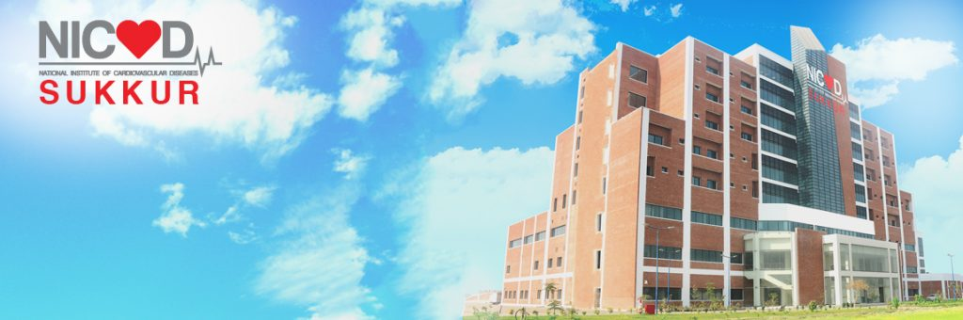
National Institute of Cardiovascular Diseases, Sukkur

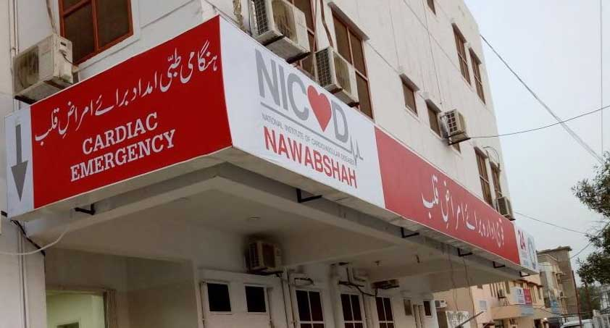

National Institute of Cardiovascular Disease, Nawabshah

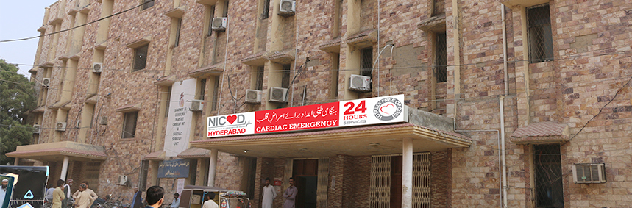
National Institute of Cardiovascular Diseases, Hyderabad
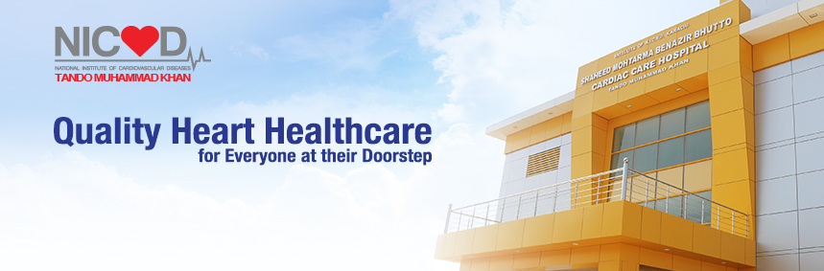
National Institute of Cardiovascular Diseases, Tando Muhammad Khan
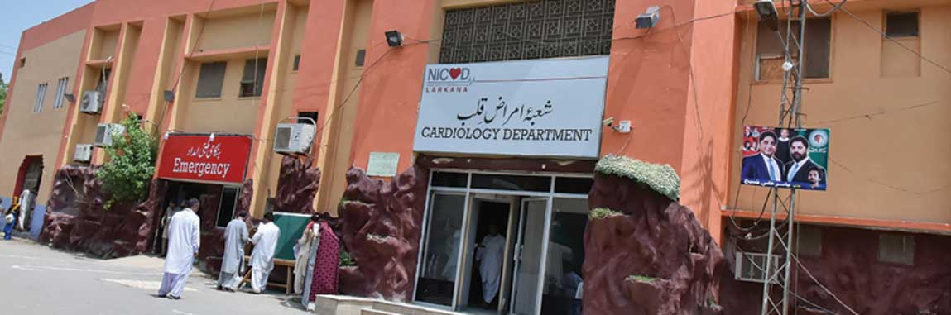
National Institute of Cardiovascular Diseases, Larkana

CHEST PAIN UNIT
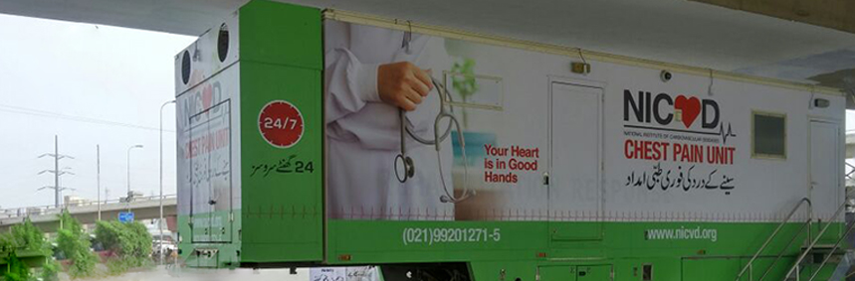
National Institute of Cardiovascular Diseases – NICVD has introduced a new era of heart healthcare with the inauguration of “Chest Pain Unit” to serve the nation at their quick approachable areas. This service is one of its kinds and is available for 24/7 throughout the year.
Chest Pain Units are launched for speedy access and fast diagnosis with early initiation of treatment of an acute myocardial infarction (heart attack), which will prevent muscle damage and ultimately enhance quality of life of the patient. This program will also educate the public to promptly seek medical care if they have symptoms of an AMI, such as chest pain, chest discomfort, shortness of breath, excessive sweating, syncope and regarding risk factors for coronary artery disease, particularly smoking.
Chest Pain Units are well-equipped facility and has the appropriate diagnostic testing available to identify patients with an acute heart attack and is also equipped to resuscitate patients who become unstable. CPUs are functionally design for providing preliminary emergency care to heart attack patients. After providing initial treatment, the patient will be shifted immediately to the tertiary care setup at NICVD Cath Lab.
Since establishment of this facility in May 2017, 20,541 patients have visited our chest pain units including 9,297 cardiac patients, who have been managed in emergency and; furthermore 1,247 lives suffering from active heart attack, were saved during till December 2017. These units are functionally designed for providing state-of-the-art initial emergency care to heart attack patients and teams of all these units are diligently working to save lives round the clock.
Currently we have our Chest Pain Units at six different locations of Karachi to facilitate the citizens.
NICVD Chest Pain Unit Gulshan Chowrangi Flyover
NICVD Chest Pain Unit Gulbai Flyover
NICVD Chest Pain Unit Qayyumabad Chowrangi Flyover
NICVD Chest Pain Unit Malir Halt Flyover
NICVD Chest Pain Unit Nagan Chowrangi Flyover
NICVD Chest Pain Unit at Railway Road, opposite Miskeen Gali near I.I. Chandrigar Road.
NICVD Chest Pain Unit Karimabad Flyover
NICVD Chest Pain Unit Landhi Flyover

